Our Untold Story – Technical Rider

Line Up:
Name | Plays | Amp | DI | Mics (Refer to patch list)
Xander Turian | Guitar/VOX | Guitar | No | 1 Vox
Kim Liljedahl | Bass/Backing Vox | Bass | 1 | 1 Vox
Viktor Gineman | Drums/Backing Vox | No | No | 1 Vox
Tommy Gustafsson | Guitar/Backing Vox | Guitar | No | 1 Vox

Equipment/Backline:
Guitar Amp (Xander):
4 x 12” cab + Top with clean channel and healthy tubes and drivers – Marshall preferred

Bass Amp (Kim):
4 x 10” cab in good condition with drivers not over driven – Ampeg or EBS preferred

Drum Kit (Viktor):
Standard 5 piece professional grade/series drum kit – Pearl, Mapex or Tama.
1 x 22”/24” KICK 2 x 10” + 12” RACK TOM 1 x 16” FLOOR TOM 3 x CYMBAL BOOM STANDS
1 x SNARE STAND 1 X HI-HAT WITH STAND 1 x DRUM THRONE
Drum kit must have all hardware, fresh heads/skins and spare cymbals stands and a good throne.

Guitar Amp (Tommy):
4 x 12” + Top with clean + lead channel and healthy tubes and drivers – Marshall preferred

All gear including back-line must be approved by band or band’s sound engineer when applicable prior to gig.

Stage Layout:

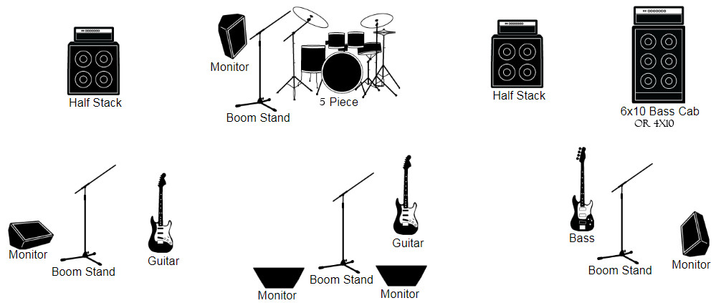
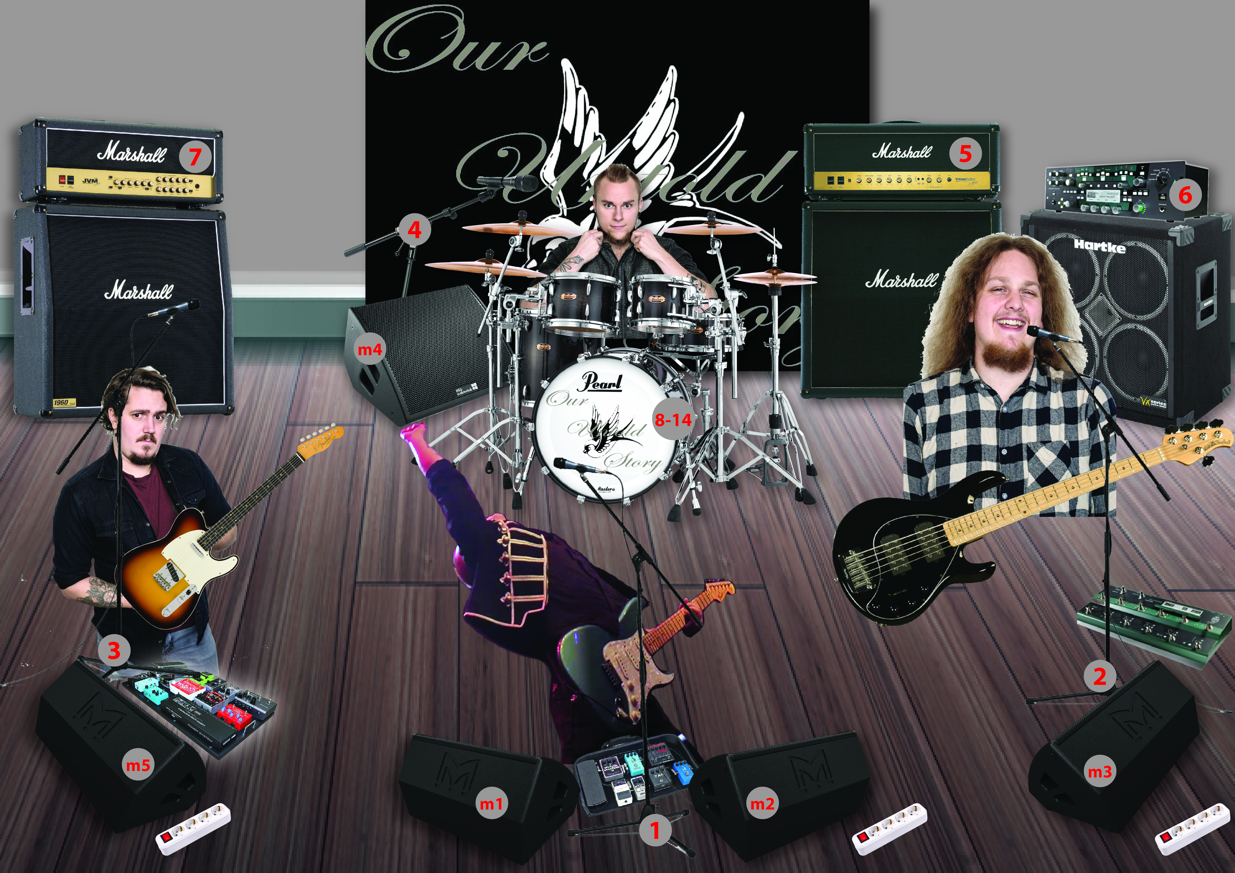

Input List:

Channel | Instrument | Mic | Stand
1 | Xander Vox | SM58 | Boom
2 | Kim Vox | SM57 | Boom
3 | Tommy Vox | SM57 | Boom
4 | Viktor Vox | SM57 | Boom
5 | Guitar (Xander) | SM57 | Small/Clamp
6 | Bass | DI | -
7 | Guitar (Tommy) | SM57 | Small/Clamp
8 | Kick Drum | Beta 52/Audix D6 | Small Heavy Bass Stand
9 | Snare | SM57 | Small (No Clamp)
10 | Hanging Tom 1 | Beta 98 | Clamp
11 | Haning Tom 2 | Beta 98 | Clamp
12 | Floor Tom | Beta 98/Beta 56 | Clamp
13 | Overhead L | SM 81 | Boom
14 | Overhead R | SM 81 | Boom

Monitor Mix/Outputs:

 | Xander (m1+m2) | Kim (m3) | Viktor (m4) | Tommy (m5)
1- Vox 1 | High | High | High | High
2- Vox 2 | - | High | Mid | Mid
3- Vox 3 | - | Low | Low | High
4- Vox 4 | - | Low | High | Low
5- Guitar | High | Mid | Mid | Low
6- Bass | Mid | High | High | Low
7- Guitar | Low | Low | Low | High
8- Kick | Mid | High | - | Mid

Sound check:

Sound check will be scheduled prior to the opening of doors. It shall not be limited as to length, doors will be held as necessary to facilitate proper sound check. Only working personnel will be allowed in venue during sound check unless authorized by band’s representative.

- No changes to the stage allowed after sound check.
- Recording audio of the performance (Audio/Video) is strictly prohibited unless otherwise negotiated.
- Production Company shall have enough mic stands and cables for the OUS stage.

The sound, stage and lighting systems must all be fully operational prior to bands load-in time.

Contact Information:

Our Untold Story is part of the XJT Music and Cuprite Productions family – www.cupriteproductions.com

Please visit www.ouruntoldstory.com for more information
Email: contact.ouruntoldstory.com

Main Contact – Xander Turian
Email: Xander.turian@cupriteproductions.com
Tel: +46 709 744 536

Please don’t hesitate to contact us for any inquiries or questions regarding our technical requirements. We are also human beings and understand that all of our needs cannot always be met to our specific requests and are happy to discuss any issues to find a solution together.
We look forward to working with you and playing at your venue/event.

